**Bresenham Circle Output :**

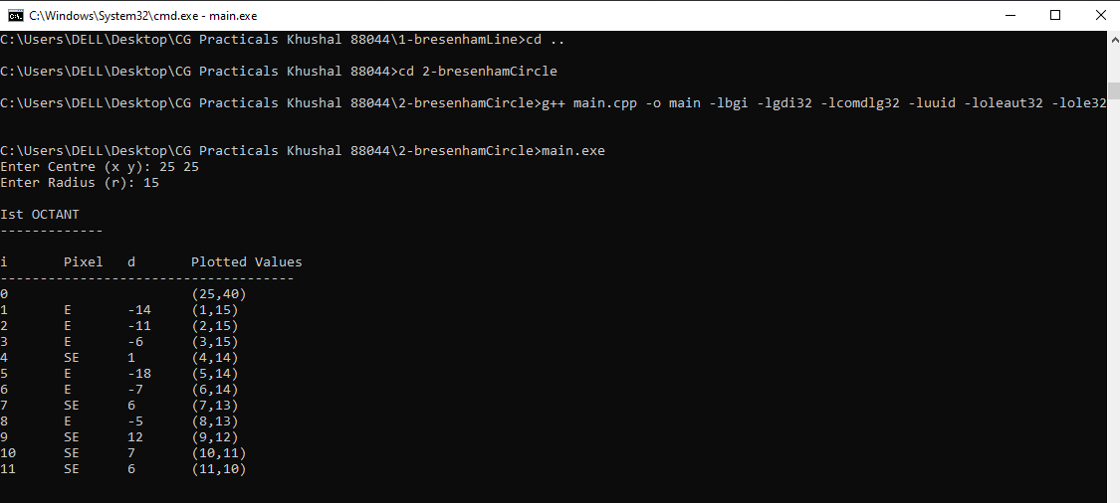

**Mid – Point Circle Drawing Algorithm :**

